Research Paper: Centrino Technology
Jim Rieger

Introduction: In this research paper I will briefly cover the history of the Centrino technology as well as some comparisons to other analogous technologies. I will also illustrate the fact that Centrino is a group of technologies not a chip codename as I had first thought. I will also try to look into the future to see where the Centrino and it’s new Core 2 Duo technology is all about.

History
In 2003 mobile processor technology took a giant leap ahead with the release of Intel Pentium M chip. Billed as Intel's "first chip designed from the ground up to power notebooks", Banias - named after an archaeological site in the Middle East - was fundamentally different from other Intel notebook chips. The architecture design of these chips was to support less power consumption and were to be used exclusively in a mobile computing environment. The previous Intel notebook chips were based on redesigned PC chips that could be used in a notebook.
. The Pentium M chips were designed more for less power consumption than for overall speed and performance. Although speed and performance continue to be a big factor in how well these types of mobile computers will sell. With the advent of the new AMD chips, Intel must continue to push the envelope to be competitive.
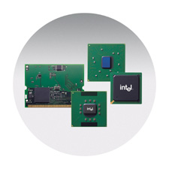
In March 2003 the first generation Centrino platform(codenamed "Montara") was announced . The major thrust of the Centrino technologies is a focus on less battery consumption and wireless LAN technology. The 3 major components comprise the Centrino brand classification of core of technologies. They are:
- A Pentium-M processor
- The Intel 855 chipset family
- An Intel Pro/Wireless LAN or Wi-Fi adapter.

The key components in the Centrino technology family
Intel
Laying the Foundation for Wireless Technology
http://www.intel.com/technology/computing/hw03031.htm

Intel was not the first to the WiFi party and was not the technological leader, but it became a big player by virtue of its platform strategy. It used its dominant position to bundle its microprocessor, PC chip sets and WiFi, thus creating Centrino. Thanks to Intel's heavy marketing of Centrino, consumers embraced WiFi faster than almost any other new technology.
In 2003 only 31 percent of all laptops had built-in WiFi. But now 61 percent of new laptops come with built-in WiFi, most of them using Centrino chip sets. With Centrino, Intel took the leading market share in WiFi chip sets for laptop computers, capturing 35 percent in 2003.
Intel did this even without making the WiFi chips itself. Because it was late in developing its own WiFi technology, the company initially relied on buying various components of WiFi from others, including Texas Instruments, Philips Electronics and Symbol Technologies.

Technical aspects
Like the Pentium III-M, the Pentium-M adopts the same design principal of performing more processor instructions per tick of the system clock. It does this without generating too much heat and can run at low voltages. In addition, it also supports the Pentium 4-M's quad-pumped 400MHz FSB and support for both SIMD and SIMD2 instructions to further boost performance. Since power consumption is directly proportional to clock speed, it is not surprising that a Pentium-M runs at lower clock than a Pentium 4-M, the new CPU being initially available is speeds from 1.3GHz to 1.6GHz. At the time of its launch, Intel claimed that a 1.6GHz Pentium-M offered comparable performance to a 2.4GHz Pentium 4-M at 50% less battery drain.
In addition to the new core, the processor's Level 1 cache has been increased to 32KB from the Pentium III-M's 16KB and the Level 2 cache is a full 1MB. However, to reduce power consumption when running on battery power, the chip only powers up the amount of L1 cache it actually needs - estimated by Intel to be 1/32 of the full cache size on average.
The new chip also introduces further refinements in Intel's established SpeedStep technology, which dynamically reduces processor speed and voltage as the situation allows. The Pentium-M's more compartmentalized processor allows finer control over shutting down the parts that aren't needed and reduces the voltage before the frequency slowly enough for the CPU to be able to continue what it's doing whilst this is happening.
The 855 chipset's features include:
- a 400MHz (100MHz x four) system bus offers a peak bandwidth of 3.2GBps
- DDR memory channels offering a peak bandwidth of 2.1GBps, and
- an AGP 4x interface allowing graphics controllers access to main memory at over 1GBps.
and the new ICH4-M Southbridge offers standard support for features that are found to be standard on mobile and desktop PC units:
- Ultra ATA/100 (hard drive)
- 10/100BaseTX Ethernet
- AC97 audio
- PC Card
- Modem
- USB 2.
The 855 chipset comes in two versions: The 855PM and the 855GM. The 855 GM also incorporates on board graphics.
The third and final Centrino component is the Intel PRO/Wireless adapter. When details of Banias were first revealed in 2002, the expectation was for the wireless networking support to be hardwired into the motherboard as part of the chipset. Wi-Fi has been implemented as a mini-PCI card and slot. This seemed to be the best working solution as wireless technology and its standards continue to increase in versatility and complexity.
PCTech Guide
All site content is available under the terms of the GNU Free Documentation License
Last updated Aug05 http://.pctechguide.com/71CPUTech_Centrino.htm

Currently

In January 2005 Intel released its second generation mobile computing device codenamed Sonoma. Due to the increase in wireless LAN user’s world wide, Intel has pushed computing from a portable device structure to a fully wireless unit.
The new Sonoma package will improve on the following Centrino core technologies:
- the i915 Graphics and Memory Controller Hub (GMCH)
- the IO Controller Hub (ICH) 6-M, and
- the Intel PRO/Wireless 2915 a/b/g Network Interface Controller (NIC)
- a number of new Pentium M processors.
The centerpiece of the Sonoma package is the 915 Express chipset, formerly codenamed Alviso, which provides the support for several new technologies expected to provide a foundation for notebook PCs for the next decade:
- mobile PCI Express (PCIe) and ExpressCard technology
- Serial Advanced Technology Attachment (SATA) interface
- PCIe External Graphics (PEG) interface
- Double Data Rate (DDR2) memory, and
- Intel High Definition (HD) Audio.
Centrino Duo
In January 2006, Intel introduced the revolutionary Intel Centrino Duo Mobile Technology platform (formerly codenamed "Napa"), the third generation of the company's Centrino mobile processor technology bundle. This new development will spur on new lighter and thinner laptops, notebooks and tablet PCs. The following three next generation components will enable Centrino Duo laptops to surpass both the performance and battery life of previous generation. Recent report have given the Core 2 Duo rave reviews in regards to speed and performance
Centrino Core 2 Duo platforms include:
- Intel Core Duo Processor
- Mobile Intel 945 Express Chipset Family
- Intel PRO/Wireless 3945ABG Network Connection.
The Intel Core Duo processor (previously codenamed "Yonah") is Intel’s first mobile dual-core processor built on the company's next generation 65nm process technology. This has enabled a pair of Yonah cores to be fit onto a die only slightly larger than the previous Dothan-cored Pentium M (90mm² compared to 84mm² for the older part).
Centrino
PCTechGuide Last Updated - 18Mar06 http://www.pctechguide.com/71CPUTech_Centrino.htm
The Mobile Intel 945 Express Chipset Family is the next generation Intel Hub Architecture for notebook PCs using Intel Centrino Duo Mobile Technology. As with previous Centrino chipsets, there are three variants: the 945PM is the plain mobile chipset, the 945GM adds integrated graphics and the 945GMS is the ultra-low voltage chipset with integrated graphics. Below is a representation of how the processor and cache all work together. Also represented is the trend toward SATA hard drive technology and PCI-E for faster graphics performance. 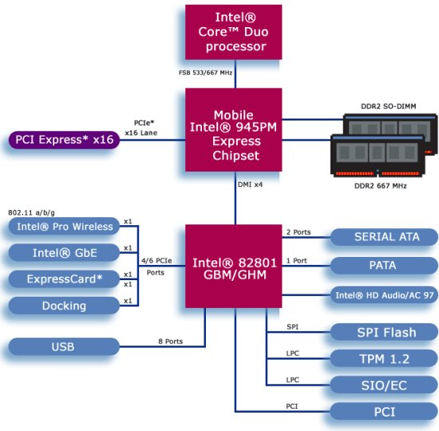
The Intel Core Processor includes several new innovative features. These include a number of changes which together eliminate limitations that have restricted the Pentium M's multimedia performance relative to that of NetBurst architecture-based chips. Referred to a Digital Media Boost, these include instruction optimizations and performance enhancements for existing Streaming Extensions 2
Another new feature is a shared 2MB L2 cache which enables an active execution core to access the full 2MB cache when the other execution core is idle. This featured named Smart Cache, uses dynamic cache allocation across both cores to enhance performance and reduce cache under-utilization and misses. Efficient data sharing between both cores minimizes FSB traffic and reduces cache coherency complexity and the processor’s enhanced Data Pre-fetch Logic speculatively fetches data to the L2 cache before cache requests occur, thereby reducing bus cycle penalties.
In the past the design of mobile processing platforms has required a trade off between performance and battery life. In the case of the Core Duo, the design goal was breakthrough performance while at the same time optimizing energy efficiency and enabling longer battery life. The result is that each of the CPU's execution cores is able to independently and dynamically transition to Halt, Stop Clock, and Deep Sleep low-power states, so that if only one core is being utilized, the second core can still enter an idle state to help save power. Moreover, Dynamic Power Co-ordination also enables coordinated transitions to Deeper Sleep and an Enhanced Deeper Sleep mode, for example when the Smart Cache dynamically flushes the cache to system memory during periods of inactivity.
The NetBurst platform was succeeded by a micro architecture that was directly based on the Pentium M, and one that Intel planned to deploy in all market sectors - mobile, desktop and server - going forward .
First Tests of Intel's New Dual-Core Mobile Processors

Carla Thornton, special to PC World
Thursday, January 05, 2006 05:00 PM PST
http://www.pcworld.com/article/124230-1/article.html

Conclusion:

This research was enlightening in regards to the features that make up the Centrino technology. It also served as an impetus to start watching the tech news sites for new updates in the battle for market shares between AMD and Intel. As one who loves speed and power, Intel seems to be on the right track. With that said, as AMD and new acquisition ATI work together to dig into Intel’s market share, it should be great days ahead as technologies get faster, more efficient and much more mobile, many of us can do our share to push the limits of computing.

